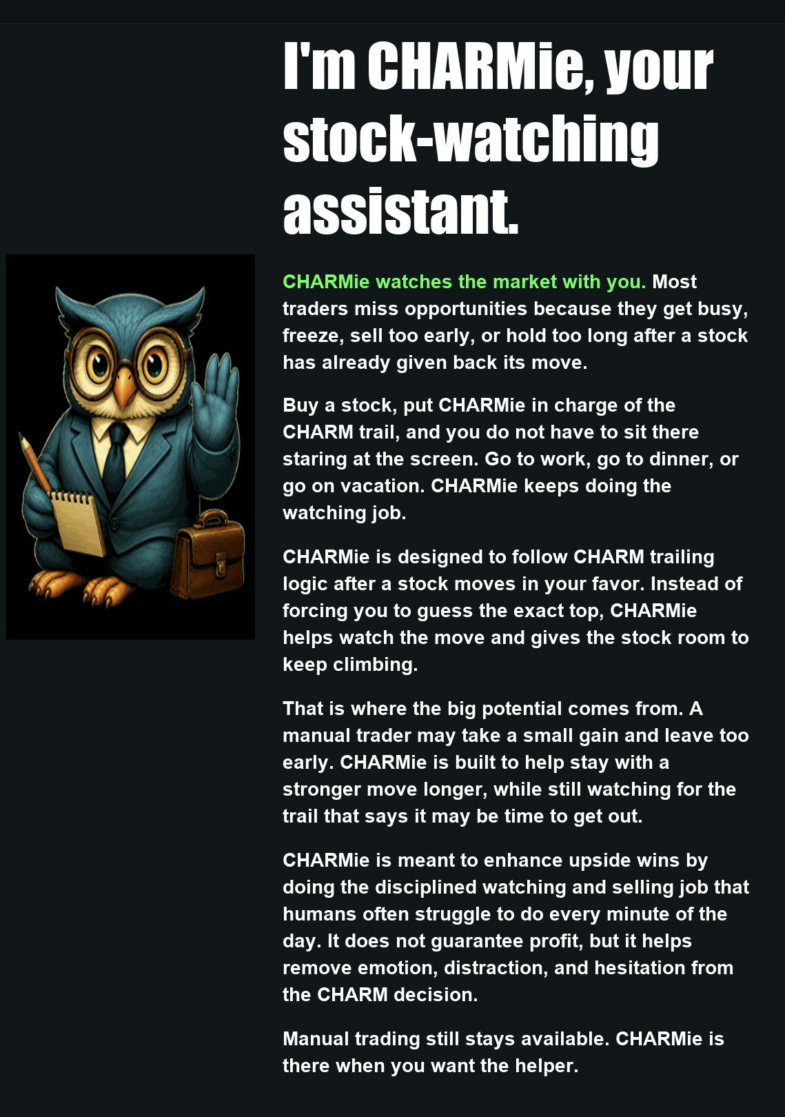


CHARM WEB SETUP
Start with PAPER. Use the two passwords below to control access.
1 Open CHARM
Go to http://173.208.162.111 in your browser. Use the same full user name on every device.
2 First time setup
Enter your name and select SETUP. A new user must enter the date serial code before Setup opens. Then fill in your details and choose both passwords.
3 Choose your two passwords
ACCESS PASSWORD
Used with ENTER CHARM to enter the website. Sign-in opens your PAPER account.
SETUP / LIVE PASSWORD
Required to open SETUP or KEY and whenever you switch from PAPER to LIVE.
Existing users: your current password works for both until you save replacements. Leave a password field blank to keep its saved value.
4 Add Alpaca keys and save
Create or sign in to your Alpaca account at app.alpaca.markets. Generate separate PAPER and LIVE API keys. Keep the Secret Keys private.
Enter each key pair in its matching section. Set your refresh rate, then select SAVE ALL. PAPER and LIVE keys are stored separately.
5 Sign in and select your account
Use your ACCESS PASSWORD to sign in to PAPER. To use LIVE, select the PAPER/LIVE control and enter your SETUP / LIVE PASSWORD.
LIVE uses real money. Confirm the account and order details before submitting a trade. Test in PAPER first.
See CONNECT TO ALPACA and CONNECT TO SCHWAB on the following pages for numbered steps and diagrams.


CONNECT TO ALPACA
Use PAPER for practice or LIVE for real money. Each uses its own pair of keys. The numbered arrows on the next page show where each item goes.
1. Get your account ready. Open https://app.alpaca.markets and sign in or create an account. For real trading, complete Alpaca's brokerage approval and funding steps.
2. Copy the correct keys. In Alpaca, choose Paper Trading or your Live account. Open API Keys and generate or view the Key ID and Secret Key. Copy both. PAPER keys will not connect a LIVE account.
3. Open CHARM Setup. Use SETUP or KEY and your existing SETUP / LIVE PASSWORD. Find PAPER ALPACA KEYS or LIVE ALPACA KEYS.
4. Paste the two keys. Paste Key ID into API KEY ID and Secret Key into SECRET KEY in the matching PAPER or LIVE section. Use your own keys, not the sample characters in the picture.
5. Check the addresses. PAPER trading: https://paper-api.alpaca.markets
LIVE trading: https://api.alpaca.markets
DATA BASE URL for both: https://data.alpaca.markets
6. Save. Select SAVE ALL in the main Setup window. Scroll if needed; it is outside the screenshot. Wait for the saved confirmation. SAVED ENCRYPTED means the keys are stored, not that you are in LIVE.
7. Check the selected account. Return to the portfolio. If Schwab is active, click ALPACA to return to Alpaca PAPER. For real trading, use the PAPER/LIVE control and your SETUP / LIVE PASSWORD. Refresh and confirm the expected account and balance.
If connection fails: check PAPER versus LIVE, recopy the matching key pair, and select SAVE ALL again. Keep your existing passwords; there is no need to change them.
Official key instructions: https://docs.alpaca.markets/us/docs/paper-trading
Connection instructions updated September 11, 2026 at 05:20 AM ET
ALPACA CONNECTION DIAGRAM
Upper section = PAPER practice. Lower section = LIVE real money. Arrows identify the fields; SAVE ALL is in the main Setup window.
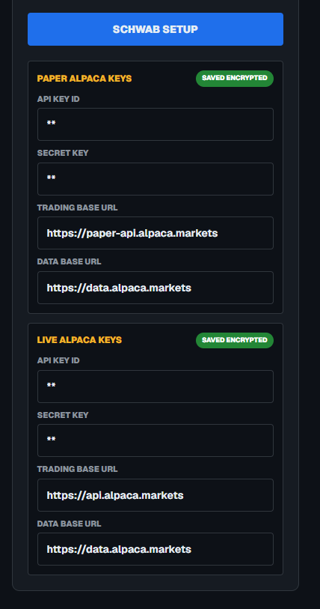
8. LIVE data URL
7. LIVE trading URL
6. LIVE Secret Key
5. LIVE Key ID
4. PAPER data URL
3. PAPER trading URL
2. PAPER Secret Key
1. PAPER Key ID
The blue SCHWAB SETUP button opens the separate Schwab connection screen. Do not enter Schwab keys into the Alpaca fields.

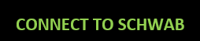
CONNECT TO SCHWAB
Schwab connects to a real brokerage account. You need an approved Schwab developer app as well as your brokerage login.
1. Prepare the Schwab app. Visit https://developer.schwab.com. Register or sign in, request Trader API Individual access, and create your app using the portal instructions. Arrange account/trading and market-data access and wait until the app is approved for use.
2. Set its callback address. Register https://127.0.0.1 as the callback URL for this CHARM setup. If your approved app uses a different callback, CHARM must use that exact same address.
3. Open SCHWAB SETUP in CHARM. Enter your existing SETUP / LIVE PASSWORD if asked. Copy the App Key from the developer portal into CLIENT ID. Copy the App Secret into CLIENT SECRET. These are not your brokerage username and password.
4. Save your keys. Check CALLBACK URL, then press SAVE SCHWAB KEYS. Wait for KEYS SAVED ENCRYPTED. A blank saved-secret field is normal: leave it blank to keep the saved secret.
5. Start sign-in. Press AUTHORIZE SCHWAB. Then press the green OPEN SCHWAB SIGN-IN link that appears. AUTHORIZE alone does not open the sign-in page. Sign in on Schwab's page and approve the intended account.
6. Copy the whole returned address. After approval, copy the entire browser address beginning with your callback URL and containing code and state. A cannot-reach-page message at https://127.0.0.1 can be expected; copy the address anyway.
7. Finish immediately. Return to the same CHARM tab. Paste the whole address into PASTE COMPLETE REDIRECTED ADDRESS, then press CONNECT ACCOUNT promptly. Aim to finish within 30 seconds, as Schwab support instructed. Do not edit or reuse an old address.
8. Verify the account. If account choices appear, select the correct ACCOUNT ENDING button. Confirm SCHWAB LIVE and the last four digits in the portfolio, then check the refreshed positions and cash.
Authorize separately on each CHARM website you use. A Direct PC connection does not automatically connect Web2. Keep keys and callback addresses private.

SCHWAB CONNECTION DIAGRAM
Match each numbered arrow to the control guide on the next page. Use your own Client ID and secret; the screenshot shows an existing saved setup.
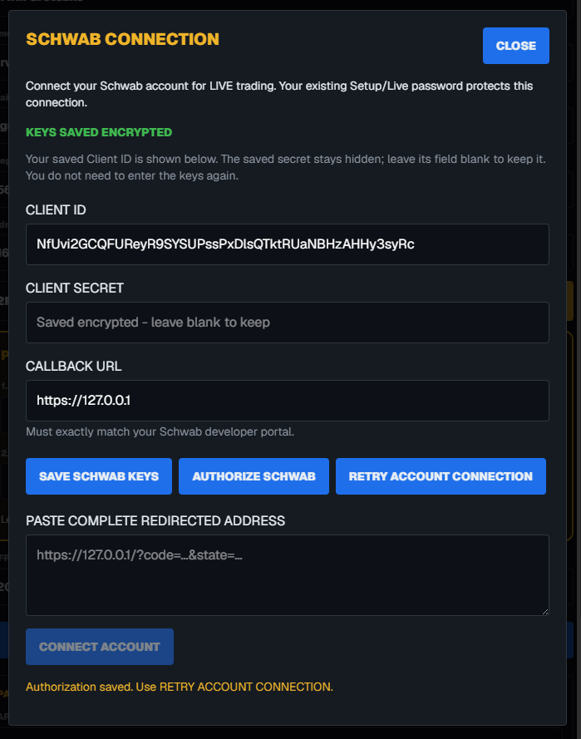
10. CLOSE
9. STATUS
8. CONNECT
7. PASTE ADDRESS
6
5
4
3. CALLBACK URL
2. CLIENT SECRET
1. CLIENT ID
OPEN SCHWAB SIGN-IN appears only after AUTHORIZE SCHWAB, so it is not visible in this saved-connection screenshot.

SCHWAB CONTROLS AND RECONNECTING
1. CLIENT ID Paste your developer App Key here.
2. CLIENT SECRET Paste your developer App Secret the first time. Once saved, leave blank to keep it.
3. CALLBACK URL Must exactly match your approved app. Usually https://127.0.0.1 for this setup.
4. SAVE SCHWAB KEYS Stores the three fields encrypted. This does not complete account authorization.
5. AUTHORIZE SCHWAB Creates a fresh sign-in link. Click OPEN SCHWAB SIGN-IN next, complete Schwab approval, then copy the returned address.
6. RETRY ACCOUNT CONNECTION Uses saved authorization to load the account again. Try this first for a temporary connection error; it does not create a fresh authorization.
7. PASTE COMPLETE REDIRECTED ADDRESS Paste the whole new callback address here, including code and state.
8. CONNECT ACCOUNT Submits the pasted address to finish authorization. It stays dimmed until an address is entered and the screen is ready.
9. STATUS MESSAGE Read the result or error here. KEYS SAVED ENCRYPTED confirms saved keys; verify SCHWAB LIVE and your account digits to confirm the selected account.
10. CLOSE Closes this popup only. To switch back to Alpaca, use the ALPACA button on the portfolio.
To reconnect: 1. Open SCHWAB SETUP. 2. Try RETRY ACCOUNT CONNECTION. 3. If CHARM asks for fresh authorization, use AUTHORIZE SCHWAB, OPEN SCHWAB SIGN-IN, and a new complete callback address. 4. Confirm the account digits again.
If nothing opens: look for the green sign-in link after pressing AUTHORIZE. If it is missing, read the status message. Do not reset your password or replace saved keys just to retry.

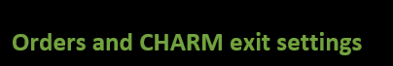
Orders and CHARM exit settings
Manual orders
Use + BUY or SELL, review the ticket, and submit once. The Schwab integration supports whole-share equity and ETF orders, with MARKET, LIMIT, STOP, and TRAILING STOP order types. A dollar amount is converted to whole shares using a current quote. Selling a held long position and buying to cover an existing short position are supported; do not assume other products or new short sales are available.
An accepted order is not necessarily filled. Check OPEN ORDERS for pending, rejected, canceled, or partially filled orders. HIST shows completed executions.
Set L S and C for a selected position
Open the stock’s settings, review the position, edit the dollar or percentage fields, and select APPLY. Use SELECT STOCKS to choose positions that CHARM may manage, then use the C control to turn monitoring on when ready.
L LIMIT — The target that allows CHARM trailing to begin when reached. Set L to 0 to disable that target and clear its stored trail.
S STOP — The adverse-price exit threshold. Set S to 0 to disable that app-managed stop.
C CHARM — The trailing distance used after the limit target is reached. C at 0 disables CHARM trailing. C alone at 0 does not disable every other exit rule.
For manual-only operation
Turn CHARM off and STOP/LIMIT off. Set L and S to 0 for positions whose automatic thresholds you want disabled, then select APPLY. Review OPEN ORDERS at the broker and cancel unwanted existing orders; entering zero does not itself cancel every broker-held order.
Broker backup protection
STOP/LIMIT ON sends CHARM backup orders when valid stop and limit values are available. For Schwab, the paired protection uses an OCO arrangement, where one leg is intended to cancel the other. OFF manages CHARM-created backups; independent manual broker orders are separate. Check cancellation status in OPEN ORDERS.
What the TRAIL value means
TRAIL is an exit price, not current profit. A price retained from an earlier move does not prove an exit filled. If the position remains open after a threshold was crossed, check the current quote, trading hours, CHARM status, and open orders. Automatic Schwab exits require fresh data and verified regular trading hours.
History and connection help
Read the portfolio and history
ENTRY is the average entry price per share; COST is the position’s total cost. PRICE is the current per-share quote, next to MKT VAL for comparison. P&L is the position gain or loss. Prices displayed to two decimals can hide fractions of a cent used in the calculations.
Select HIST, choose the date range, and select RETRIEVE. Use a column heading to sort. Fills belonging to the same order are combined where an order ID is available, with total quantity and a weighted average fill price; separate orders remain separate.
CHARM profit over limit is reserved for positive additional profit on a CHARM trailing exit when the original limit is known. It is not a second P&L column and should not report stop-loss amounts as trailing profit.
Schwab says invalid client or Unauthorized
Recopy the Client ID and Client Secret from the portal, verify the correct fields and callback URL, and save them. Check I versus 1 and O versus 0. Then start a fresh authorization. Changing a saved credential can require authorizing again.
Authorization is saved but account lookup fails
Use RETRY ACCOUNT CONNECTION. A temporary account-service error does not necessarily require entering your keys again. If it persists, note the error text, request identifier, and time for Schwab support at traderapi@schwab.com. Do not include passwords, secrets, or a reusable authorization header in this guide or screenshots.
Expired code or callback mismatch
Select AUTHORIZE SCHWAB again and use only the latest complete returned address. Return to the same CHARM site and session that started authorization. Do not reuse a code from an earlier attempt.
Rate limit or invalid JSON
“Rate limit exceeded” means a service is refusing requests sent too frequently. An “Unexpected token <” or invalid-JSON error means the app received an HTML response where it expected data. Check the connection and error status; do not assume that the displayed prices are fresh or that an order failed to reach the broker.
An order times out or its result is unclear
Check OPEN ORDERS and the broker account before submitting again. CHARM blocks some repeat requests to reduce duplicate orders. If the account view still shows the wrong broker, check its label and use ALPACA or SCHWAB SETUP to select the intended account.
CHARM help: info@charmtrader.com. Keep the browser connected while using app-managed exits. Broker-held orders can remain active after the browser closes.
CONTROLS

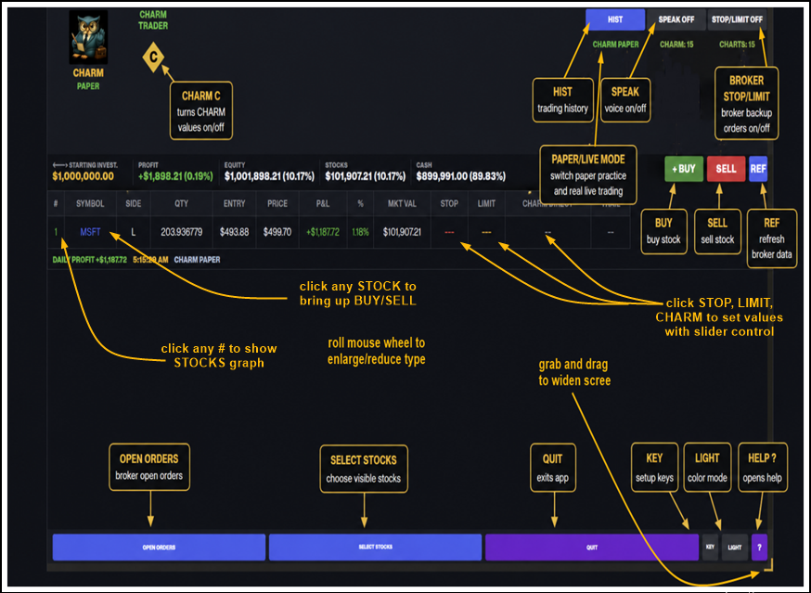


WELCOME TO CHARM TRADER
CHARM Web quick start
Use CHARM in a browser on your computer, phone, or tablet. Start in PAPER to practice before using LIVE.
Open the website
Go to http://173.208.162.111. Use the same full user name on every device.
New users
Select SETUP and enter the date serial code. Complete your details and choose the two passwords below. Then select SAVE ALL.
Your two passwords
ACCESS PASSWORD — Sign in with ENTER CHARM. This opens your PAPER account.
SETUP / LIVE PASSWORD — Open SETUP or KEY, or switch from PAPER to LIVE.
Existing users can use their current password for both roles until they save replacements. Leave a password field blank to keep its saved value.
Save your Alpaca keys
Open Setup with your SETUP / LIVE PASSWORD. Enter the PAPER key pair in the PAPER section and the LIVE key pair in the LIVE section, if needed.
Choose your refresh rate and select SAVE ALL. Keep Secret Keys private. Check that the keys show as saved encrypted.
Use PAPER or LIVE
Sign in with your ACCESS PASSWORD to use PAPER. To switch to LIVE, select the PAPER/LIVE control and enter your SETUP / LIVE PASSWORD.
LIVE places real trades. Check the account summary and order details before submitting. Test the features you plan to use in PAPER first.
Phone access
Scroll to see controls that do not fit on screen. Add CHARM to your home screen for easier access. MORE opens extra controls.
Using CHARM
Choose the positions CHARM may control, set your exit values, and select APPLY.
Set L S and C
L — LIMIT: the target that starts CHARM trailing when reached.
S — STOP: the exit level if the trade moves against you.
C — CHARM: the trailing percentage used after the limit is reached.
Open a stock’s settings to review or change these values. Select APPLY to save them. The TRAIL column shows a price once trailing starts.
Choose what CHARM controls
Use SELECT STOCKS to choose positions. Use the C control to turn CHARM on or off for the selected stocks.
Broker backup protection
STOP/LIMIT ON sends backup protection orders for selected positions with stop and limit values. OFF cancels CHARM’s backup orders and stops new ones. Manual broker orders are separate.
Find the main controls
BUY and SELL — Open an order ticket. Review the symbol, side, amount, and order type.
HIST — View history for the selected PAPER or LIVE account. Use the date range and RETRIEVE to load fills.
Row number — Open that stock’s chart.
SETUP or KEY — Open settings with your SETUP / LIVE PASSWORD.
SAVE ALL — Save setup changes, including passwords, keys, refresh rate, and 2FA.
MORE — Show additional controls and help.
Before using LIVE
Confirm that PAPER tests work, the correct LIVE keys are saved, and the displayed account is yours. Keep passwords and Secret Keys out of screenshots.

Detailed CHARM help file from the website.
This Help can read itself aloud in your phone's built-in voice, highlighting each word as it is spoken so you can follow along - no internet needed.
PLAY Starts reading the help aloud from the top, highlighting each spoken word.
PAUSE Pauses the voice where it is.
GO Continues reading from where you paused.
X Stops the voice and closes Help.
* WELCOME TO CHARM TRADER
SELECT PAUSE THEN SELECT ANY * HEADING TO LISTEN TO THAT INSTRUCTION READ ALOUD
CHARM TRADER offers BOTH paper and live trading: practice in Paper mode, then switch to Live mode to trade real money with the exact same screens - watch the account, manage positions, place orders, and let the CHARM exit method protect every position.
The screen is designed for quick decisions. Green means gain, red means risk, gold marks targets, and the bottom bar keeps the main tools one tap away.
* BROKERDIRECT SETUP
CHARM Direct connects straight to the broker using the PAPER and LIVE Broker Connect keys saved on this device.
Use SETUP to save your startup key, account label, and PAPER/LIVE datafeed API key and base URL.
Access codes, admin choices, speech, grid, CHARM, chart, and selector settings are stored locally in this delivered Direct version.
CHARM Direct places BUY, SELL, CHARM, chart, and STOP/LIMIT broker-backup actions straight through Broker Connect.
* CORE TRADING RULE
Before any BUY or SELL, CHARM Direct first refreshes the current account and positions directly from the broker/datafeed. CHARM then takes the requested action using that current broker state.
This rule applies to both CHARM Direct PC and CHARM Direct Cell so trades are based on the newest broker account status available to that device.
* WHAT CHARM DOES
CHARM is the exit-control system for positions you already own. It does not choose what to buy. It helps manage when to get out after you are in a stock.
When you tap the gold C, CHARM calculates three values for each selected stock: L, S, and C. L is the LIMIT profit target area, S is the STOP loss protection area, and C is the CHARM trailing percentage used after the stock reaches the limit area.
Before the limit is reached, CHARM watches the STOP and LIMIT values. If price falls to the STOP area first, CHARM can send a market sell to protect from further loss. If price rises to the LIMIT area first, CHARM marks that stock as a winner and starts using the trailing logic.
After the limit is reached, CHARM does not automatically sell just because the stock touched the limit. Instead, CHARM lets the stock keep running and watches the best price reached after the limit hit. The TRAIL value moves up with the stock, using the C percentage to decide how much room to give it.
If the stock later falls back to the CHARM trail, CHARM can send a market sell. This is designed to help keep part of the move while still allowing a strong stock to continue upward.
The table shows this process: STOP is the red protection price, LIMIT is the gold target price, CHARM shows the C trail percent, and TRAIL shows the live trailing sell area after the limit has been reached.
You can adjust one stock at a time by tapping its CHARM cell. The popup shows LIMIT PRICE, STOP PRICE, and LIMIT + C = TRAILING. APPLY saves the changed values for that row. RESET returns that row to CHARM's calculated values. REMOVE CHARM clears that row's L, S, and C values.
SELECT STOCKS restricts which positions CHARM is allowed to control. Checked stocks can receive CHARM values, be monitored, and be sold by CHARM. Unchecked stocks stay visible, but CHARM does not calculate, monitor, or sell them.
STOP/LIMIT broker backup is optional. When STOP/LIMIT is ON, CHARM also sends backup stop/limit protection orders to the broker for selected positions that have CHARM stop and limit values. CHARM still stays in control and cancels those broker backup orders before firing its own market sell order.
When STOP/LIMIT is OFF, CHARM does not place broker backup stop/limit orders. CHARM still watches locally in the app and can still send its own market sell order when the STOP or TRAIL trigger happens.
CHARM watches only while the app is open, awake, refreshed, and the market is confirmed open. If the phone sleeps, the app is closed, or the market is closed, CHARM is not actively watching prices.
CHARM does not promise profit, does not replace your judgment, and does not remove risk. Manual BUY, SELL, CLOSE POSITION, STOP, LIMIT, and order tools remain available at all times.
* REAL-TIME TRADING - SCREEN STAYS ON
While the market is open (Monday to Friday, 9:30am to 4:00pm Eastern), this app holds the screen ON the entire time it is showing - it will not dim or go to sleep, whether or not CHARM is active. When the market closes, the screen is released and times out normally to save battery.
WHY THIS MATTERS: real-time trading only works while the app is awake and watching. If the screen sleeps or you switch to another app, prices are NOT being watched, CHARM cannot protect your positions, and any sell that was missed is NOT made up later - this app never sells late at a worse price.
IF YOU WANT REAL-TIME TRADING: open the app, plug in the charger, and leave the app front and center during market hours. The app does the rest - it stays on all day and lets the screen rest after the close. Pressing the power button or leaving the app stops the watching until you return.
* THE BEST OF BOTH WORLDS
CHARM Direct PC and CHARM Direct Cell both connect directly to the broker. PC can monitor positions all day, while Cell can be used to buy, sell, review charts, or change settings when you are away from the PC.
Open CHARM Cell at any time to buy and sell or change settings, then exit the app when the PC is handling the monitoring task.
CHARMie - your stock-watching assistant
CHARMie watches the market with you. Most traders miss opportunities because they get busy, freeze, sell too early, or hold too long after a stock has already given back its move.
Buy a stock, put CHARMie in charge of the CHARM trail, and you do not have to sit there staring at the screen. CHARMie keeps doing the watching job while you work, sleep, eat, travel, or go on vacation.
CHARMie is designed to help protect gains, catch exits you may miss, and give a winning stock room to keep running. It does not promise profit. Manual buy, sell, close, and order tools still stay available.
* SUMMARY BAR
INVESTED Total cost basis of all open positions.
PROFIT Unrealized P&L across all positions (red = loss, green = gain). The portfolio status also shows Day P&L on its own line; a negative Day P&L number is red.
EQUITY Your total account value (cash + stocks).
STOCKS Current market value of all open positions.
CASH Uninvested cash available in your account.
* SPEAK ON/OFF
SPEAK ON/OFF is in the top controls. Turn it on to hear selected position status, submitted buy/sell orders, and automatic CHARM sell alerts. Turn it off to keep trading silent.
* STOP/LIMIT BROKER BACKUP
STOP/LIMIT is in the top controls. When ON, CHARM sends backup stop/limit protection orders to Alpaca for positions that already have CHARM stop and limit values.
The broker holds the backup stop/limit, CHARM stays in control, and CHARM cancels those broker backup orders before CHARM fires its own market sell order.
When STOP/LIMIT is OFF, no CHARM stop/limit backup orders are sent to Alpaca. CHARM still watches locally and sends its own market sell order when a CHARM trigger occurs.
Turning STOP/LIMIT OFF cancels any open CHARM-created broker backup stop/limit orders. Manual orders and regular CHARM watching still remain available.
* POSITION TABLE COLUMNS
# Row number on a green background. Tap the # to open the STOCK CHART for that position.
SYMBOL Stock ticker. Tap the SYMBOL to open the BUY / SELL menu - this is the ONLY place the menu opens; taps elsewhere on the row do nothing.
SIDE L = Long (bought). S = Short (sold short).
QTY Number of shares held.
ENTRY Average price you paid per share.
PRICE Current live market price.
P&L Unrealized profit or loss in dollars.
% Unrealized profit or loss as a percentage.
MKT VAL Current total market value of this position.
STOP Your stop-loss price. Tap to set or clear. Shows red.
LIMIT Your limit price. Tap to set or clear. Shows gold.
CHARM Always visible so a new purchase can be protected later. Tap this cell to open the L / S / C CHARM sliders for that row.
TRAIL Appears when CHARM is active. Tap it to open PROTECT PROFIT and control the trailing lock in dollars.
When you tap a CHARM cell, the popup shows that stock's L, S, and C values on three lines: LIMIT PRICE, STOP PRICE, and LIMIT + C = TRAILING. Each line has its own slider, with the slider starting in the middle so you can move the value up or down.
Use the + and - buttons above a value to widen or tighten that slider's range. RESET returns the popup to the original CHARM values and original ranges. APPLY writes the selected L, S, and C values into that row. CANCEL leaves the row unchanged.
REMOVE CHARM clears all L, S, and C values for that one row. A new purchase starts with no L, S, or C values entered, but the CHARM column stays visible so you can add them when you are ready.
Tip: Swipe left/right on the table to see all columns. Tap the CHARM or TRAIL cell and it turns grey so you can see exactly which row you are changing.
* SELECT STOCKS - CHARM STOCK SELECTOR
Tap SELECT STOCKS on the bottom bar to choose which open positions CHARM is allowed to control. The selector is scrollable so it can handle many stocks.
Checked stocks are controlled by CHARM. Unchecked stocks stay visible in the table, but CHARM does not calculate, monitor, or sell those stocks.
Selections are remembered separately for PAPER and LIVE. If you have never saved a selection, CHARM treats all loaded positions as selected, just like the PC version.
After saving, applying CHARM previews and writes L, S, and C values only for the checked stocks. Unchecked stocks have their CHARM values cleared and are marked out of CHARM control.
* STRETCH & SCROLL
The screen can be stretched at any point to a very large size.
Just place 2 fingers on the screen and separate them.
Scrolling while stretched can be achieved by simply pressing on screen for a short time until it locks, and then you can drag it in any direction.
* PLACING ORDERS
+ BUY Opens a new buy order for any symbol.
SELL Opens a new sell or short order.
Order Types:
MARKET Executes immediately at current market price.
LIMIT Executes only at your specified price or better.
STOP Triggers a market order when price hits your stop.
TRAILING STOP Stop that follows the price up by a % you set.
* POSITION ORDER PANEL
Tap any position row to open the full order panel for that stock.
BUY / SELL Toggle to switch order direction.
Quantity Pre-filled with your current shares. Change to add or reduce.
PLACE ORDER Submits the order immediately.
Scroll Scroll inside the panel to reach all fields and buttons.
* SETTING STOP & LIMIT MANUALLY
Tap the STOP or LIMIT cell directly in the table row. A small popup appears type the price and tap SET. Tap CLEAR to remove it.
* BOTTOM BAR
OPEN ORDERS Shows all pending orders. Tap CANCEL ALL to cancel them.
SELECT STOCKS Opens the scrollable CHARM Stock Selector so you can restrict which positions CHARM controls.
QUIT Closes the app. Asks you to confirm first.
* THE [ ... ] BUTTON - THE HIDE PANEL
The [ ... ] button at the bottom-right keeps the less-used controls hidden so the bar stays tidy. Tap [ ... ] and five buttons slide out: KEY, W/B, ?, H and V. Tapping KEY, W/B or ? does its job and folds the panel back to the [ ... ] button. Tap [ ... ] again any time to show or hide them.
KEY Update your datafeed API key and base URL.
W / B Toggle between white mode (W) and dark mode (B). Tap W to switch to white all text becomes bold and dark for readability. Tap B to return to dark mode.
? Opens this Help screen.
Gold C The gold circle with the black C is the CHARM control. Tap it to apply CHARM values; long-press it for CHARM Admin.
H Turns the table's HORIZONTAL grid lines (the lines between rows) on or off. Green = on, grey = off.
V Turns the table's VERTICAL grid lines (the lines between columns) on or off. Green = on, grey = off.
* TRADE HISTORY
Tap H in the top bar to open Trade History. All BUY and SELL orders are recorded automatically with timestamp, symbol, quantity, and sale type.
Sale Types STOP LOSS, CHARM PROFIT, CHARM TRAIL STOP, MANUAL MARKET, MANUAL LIMIT, CLOSE POSITION.
Email Tap EMAIL to send the full history to any email address.
Retrieve Open HIST, tap RETRIEVE, choose the START DATE, enter DAYS BACK TO RETRIEVE, then tap RETRIEVE to load that date range.
* REFRESH & MARKET HOURS
Data refreshes every 5 seconds automatically. Tap to refresh manually at any time.
Market hours: MonFri 9:30am 4:00pm Eastern Time. Outside hours you will see 'Market Closed' your last known data stays on screen until the market reopens.
* STARTUP KEY
When you first launch the app, you create a startup key (password) to protect the local Direct app on this device.
ENTER Type your startup key and tap ENTER to log in.
CHANGE KEY Tap to update your startup key. Enter the new key twice to confirm. The app returns to the login screen with the new key active.
* SETTINGS
Tap KEY in the bottom bar to update your datafeed settings at any time.
Use the Paper/Live selector carefully. Paper uses paper Broker Connect keys. Live connects to real trading if live keys are saved and selected.
Tap FETCH KEYS to load a Broker Connect key file from your phone instead of typing keys by hand. A two-key file updates the selected mode; a four-key file updates Paper and Live.
Tap EMAIL SAVED KEYS to open an email draft containing the saved Paper and Live keys, useful when you need to verify what is on the device.
* PAYMENTS AND ACCESS
CHARM: XX Shows the paid CHARM days remaining.
LIVE: XX Shows the paid LIVE days remaining. When LIVE days are 0, the LIVE control changes to KEY.
PAPER Paper trading is no longer free. CHARM use requires active paid CHARM access.
PAYPAL CHARM and LIVE payments use the same PC CHARM PayPal/admin values used by CHARM Cell.
* THE CHARM ASSISTANT
CHARM is built for a trader who wants help making cleaner exit decisions.
You are still in charge. CHARM is the assistant. It helps you see the choices, then follows the choices you make.
The goal is simple: stop guessing, pick your plan, and let CHARM watch the trade for you.
* THE BIG IDEA
Every trade needs an exit plan. Most new traders know how to buy, but they freeze when it is time to sell.
CHARM helps by turning the exit plan into three simple settings: L, S, and C.
You move the sliders. You choose the numbers. CHARM follows your plan.
* L, S, AND C
L means LIMIT. This is where you want the trade to win.
S means STOP. This is where you want to stop the loss if the trade goes wrong.
C means CHARM trail. This is the room you give a winning stock so it can keep running without giving everything back.
CHARM shows these in dollars and percent so the choice is easier to understand.
* HOW TO USE CHARM
1. Buy or select a stock.
2. Open the CHARM settings for that stock.
3. Look at L, S, and C. Do the numbers make sense to you?
4. Move the sliders if you want different numbers.
5. Tap APPLY. Now CHARM watches using the values you picked.
* WHAT CHARM DOES FOR YOU
CHARM watches the stock while the market is open.
If the stock hits your stop, CHARM can help get you out.
If the stock reaches your win area, CHARM can switch into trail mode.
If the stock keeps climbing, CHARM gives it room.
If the stock turns back down, CHARM follows the plan you chose.
* PROTECT PROFIT
Protect Profit is for a stock that is already winning.
It asks one simple question: how much of this win do you want to protect?
Move the slider toward more protection if you want to lock in more money.
Move the slider toward more room if you want to give the stock a chance to keep running.
There is no perfect answer. You pick what feels right for that trade.
* IMPORTANT
CHARM is a helper, not a promise.
You can still lose money trading.
You can change settings anytime.
You can remove CHARM from a stock anytime.
You can still buy, sell, close, or cancel orders yourself.
* QUICK EXAMPLE
1. You buy a stock at $100.
2. You set L near $110 because that is where you would like to win.
3. You set S near $95 because you do not want the loss to get bigger than that.
4. You set C so the stock has room to move if it starts winning.
5. After you apply it, CHARM watches that plan for you.
* REMEMBER
You decide.
CHARM helps you see the possibilities.
CHARM follows the \decision you made.


16748 Willow Creek Drive
Delray Beach, FL 33484
(561) 232-8919
info@charmtrader.com

